January 13th, 2008
Hi
A variety of things to comment on this week.
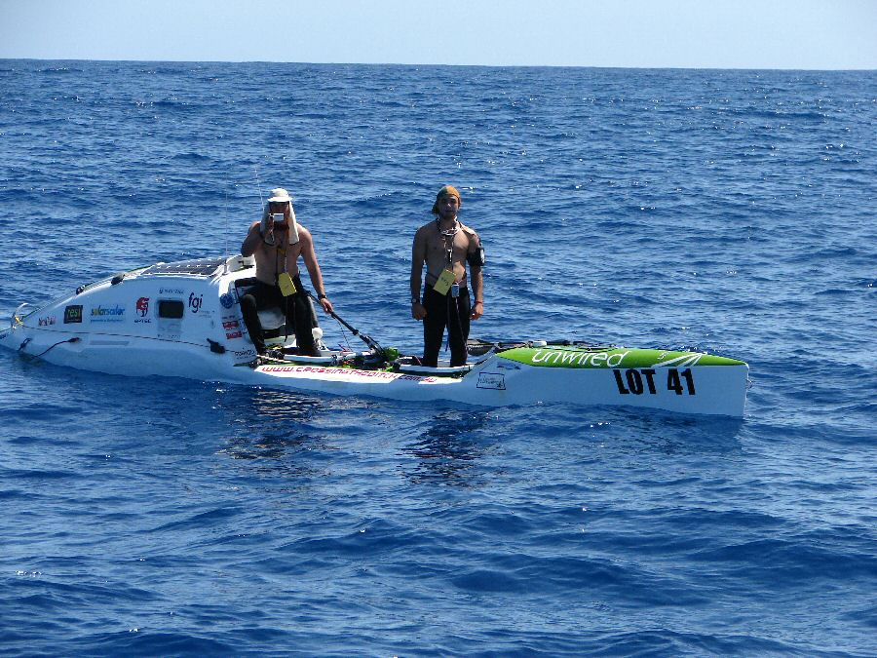
About 2 hours ago, two Australians completed the first kayak crossing of the Tasman Sea from Australia to NZ. They had paddled for 3000 km, 1000 km more than they had expected and took several weeks longer than they thought.
In HK, in the Tuen Mun hospital, a man died from a bacterial infection from a blood transfer. It is very rare for this to happen.
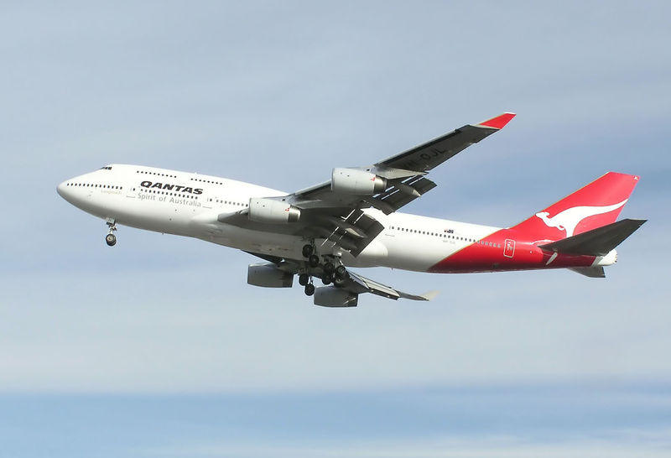
The other day a Qantas B747 had a narrow escape of a flight from London to Bangkok. It lost electrical power from all its 4 generators and had to use its emergency batteries which last just 1/2 hour! Fortunately it was only 15 minutes from the airport and landed safely. Had it been further than this, it would have had to crash land on land or in the sea. The problem is though to have been caused by water leaking from one of the galleys.
On Thursday, I went again to the dermatology clinic. There had been another rotation of doctors, which is very annoying, as you have to explain everything from scratch.
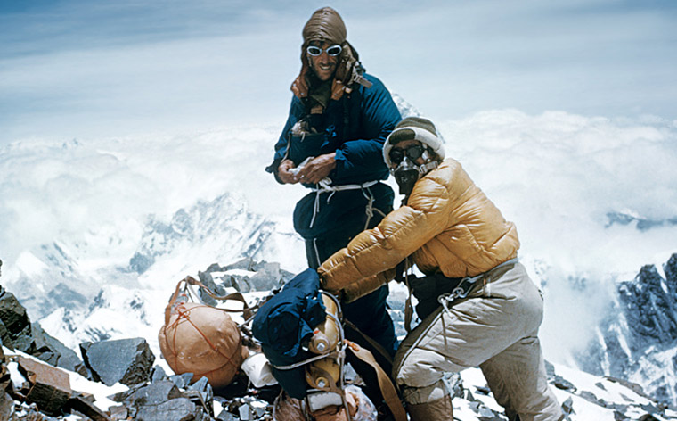
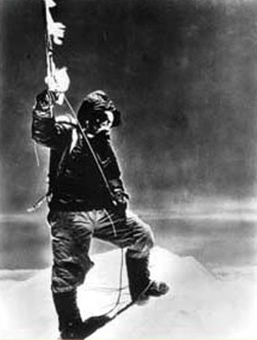
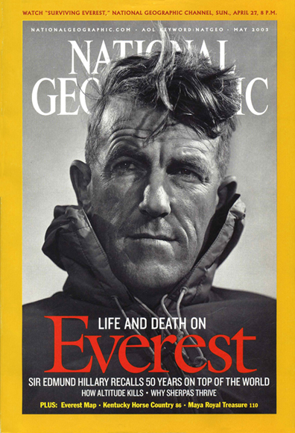
The big news of the week I suppose is the death, on Friday, of Sir Edmund Hillary, aged 88. I assume I do not have to tell you who he was! I can quite clearly remember the conquest of Everest in 1953 by him and the Sherpa Tenzing Norgay, which occurred just a few days before the coronation of the Queen. The black-and- white photo shows Tenzing on the summit – the only picture taken. The pair would not say who of the two actually got to the top first until just a few years ago when Tenzing said that it was actually Hillary. However, as Hillary said, they both got to the top together as they were attached to the same rope. He will also be mourned in Nepal where he spent a lot of the rest of his life building schools, houses and hospitals for the Sherpa people and became an honorary citizen of the country. He is to have a state funeral in NZ. In 1995, Hillary Clinton (whose first name also has the less common two ‘l’s), claimed that she was named after the climber, but later admitted that this was not true.
Yesterday was very hot for the run at about 26⁰C. In some parts of HK it was up to 30⁰C – and this is supposed to be the middle of winter! However, a cold front passed over HK last night bringing temperatures down by about 10⁰C. It often seems to happen that we get a very hot day before the arrival of a cold front. My hypothesis is that the cold front, rather than mixing with the warm air it meets (like mixing hot and cold water to get an intermediate temperature) actually pushes back the warm air thus causing the temperature to rise. I ran from Tai Mei Tuk up and along the Pat Sing Leng range to the tiny reservoir at Hok Tau. After one hour I was just 2 minutes behind my previous time for this route but after two hours was 12 minutes behind. I then decided not to do the last planned leg up Cloudy Hill and returned to Tai Po via Sha Lo Tung (where I was one chased by that wild pig!) but it took longer than expected.
That’s about it for now.

Cheers

